SESSION 31.2: EXCEL ANALYTICS (CONTD.)

4. Associated Data Files
Use “Sales_Dataset.xlsx” file

5. Problem Statement

- Create and execute a macro (show a button), to sum of “Sales” where the “attractiveness” rating is more than 5.

- Do it by recording a Macro.
- Try it using writing a VBA code in Macro.

- Use http://www.excel-easy.com/vba.html for reference to write VBA script.
- Protect the Workbook and save version and upload as a first part of assignment

- Share the protected workbook, by giving edit access and implement track change. Upload this workbook as second part of your assignment.

Note: Both upload should contain macros (two types as mentioned above).

• Protect the Workbook and save version and upload as a first part of assignment

Answer:-

Protected sheet – Password --- password@123456
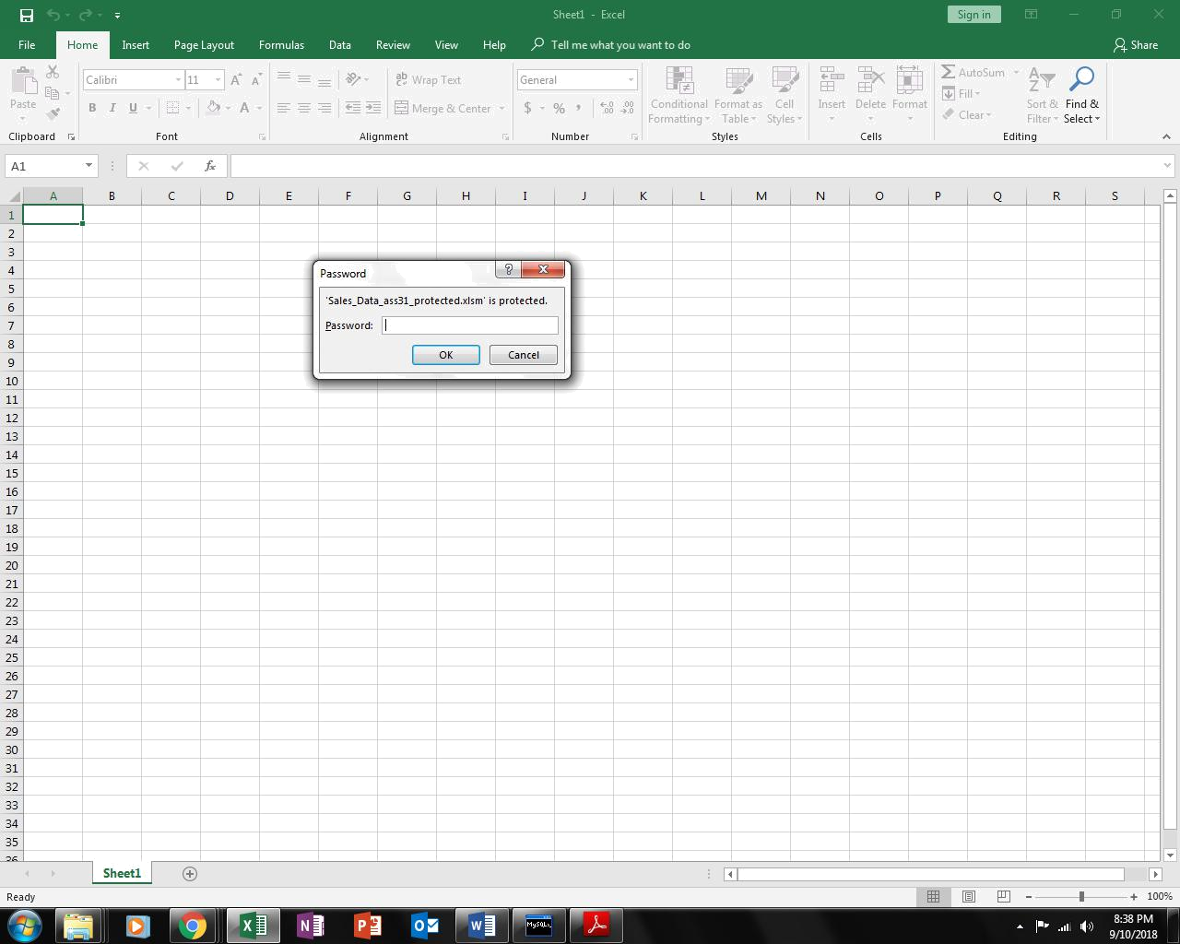
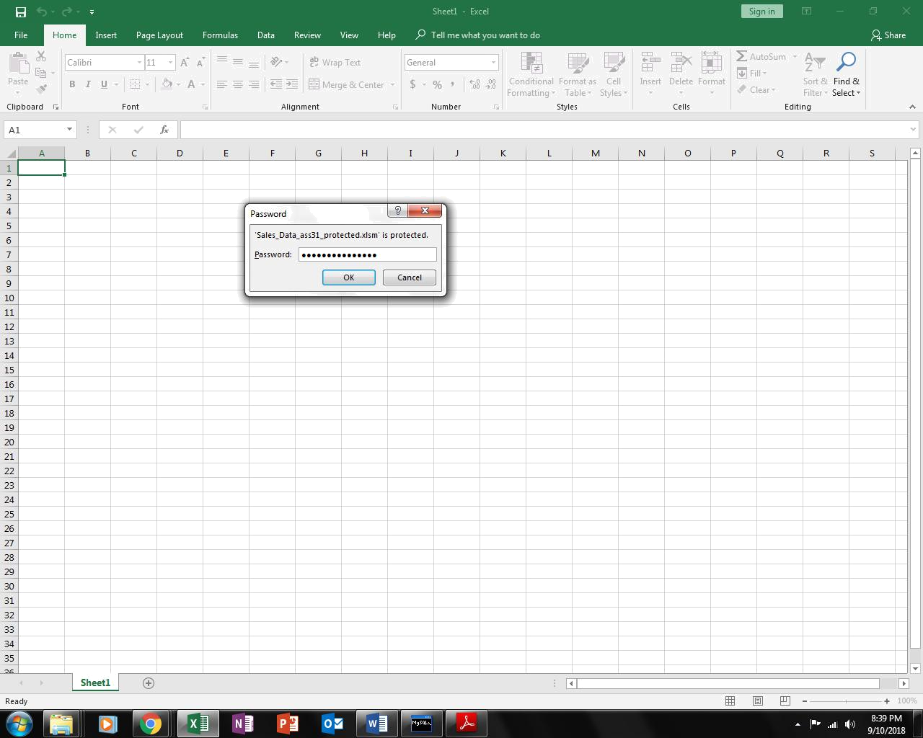
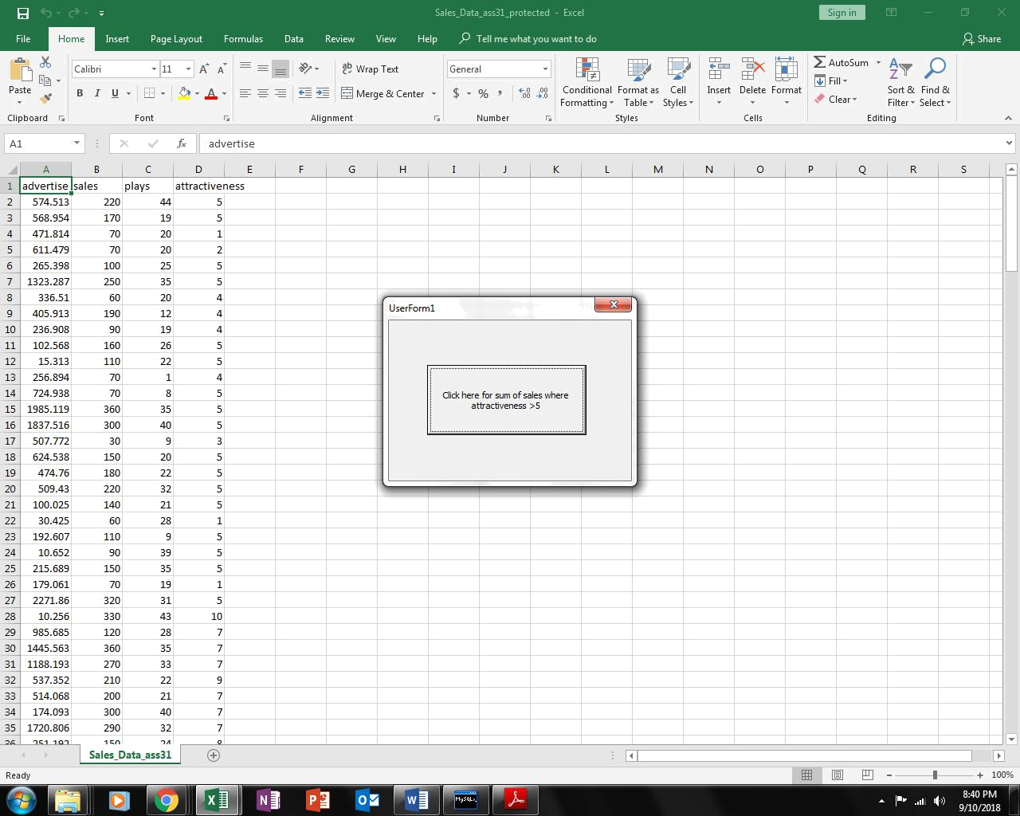
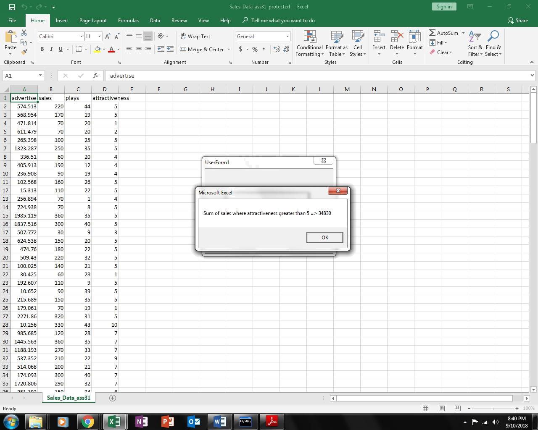

Second Part of the Assignment

- Share the protected workbook, by giving edit access and implement track change. Upload this workbook as second part of your assignment.
